**Report of Percentile:**

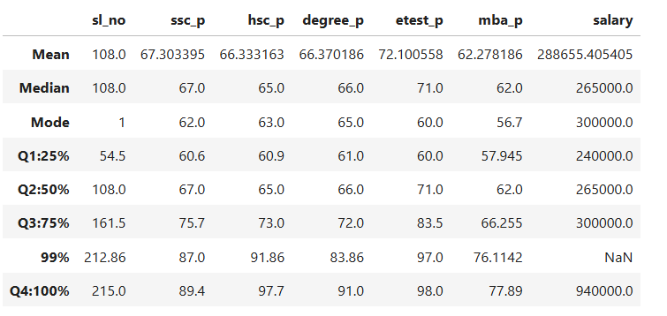

**SSC (Secondary School Certificate):**

* 25% of students scored upto 60.6%
* 50% of students scored upto 67.0%, here 7% improvement over the 25th percentile
* 75% of students scored upto 75.7%, here showing additional 8% improved
* 99% of students scored upto 87.0%, with significant 12% increased
* 100% of students scored upto 89.4%, here 2% increased

**HSC (Higher Secondary Certificate):**

* 25% of students scored upto 60.9%
* 50% of students scored upto 65.0%, here 5% improvement over the 25th percentile
* 75% of students scored upto 73.0%, here 8% improved
* 99% of students scored upto 91.86%, here scores are significantly higher 18% increased
* 100% of students scored upto 97.7%, here 6% increased

**Degree:**

* 25% of students scored up to 61.0%
* 50% of students scored up to 66.0%, reflecting a 6% improvement over the 25th percentile
* 75% of students scored up to 72.0%, showing a further 6% increase
* 99% of students scored up to 83.86%, indicating an 11% improvement
* 100% of students scored up to 91.0%, marking a significant 18% increase over the 75th percentile

**E test:**

* 25% of student scored upto 60%
* 50% of student scored upto 71.0%, here 11% improvement over the 25th percentile
* 75% of student scored upto 83.5%, here 12% improved
* 99% of student scored upto 97%, here 14% increased hence it is highest performance
* 100% of student scored upto 98%, here 1% increased

**MBA:**

* 25% of student scored upto 57.94%
* 50% of student scored upto 62%, here 5% improvement over the 25th percentile
* 75% of students scored upto 66.25%, here 4% improved
* 99% of students scored upto 76.11% here 10% of significantly increased
* 100% of students scored upto 77.89, here 1% increased

**Salary:**

* 25% of students, earned upto 24000
* 50% of students, earned upto 265000
* 75% of students, earned upto 300000
* 99th percentile of data is missing i.e not available
* 100% of students, **maximum salary (940k)** is over 3 times higher than the 75th percentile